SUPPLEMENTAL MATERIAL
of
Redefining AT1 receptor PET Imaging: Introducing the Radiotracer [¹⁸F]DR29

Xinyu Chen PhD¹, Hiroyuki Kimura PhD², Takanori Sasaki PhD³, Konrad Klimek MD⁴, Saskia Mühlig MSc⁵, Anahi Paula Arias-Loza PhD⁵, Naoko Nose PhD³, Yusuke Yagi PhD^{3,6}, Steven P Rowe MD⁷, Constantin Lapa MD¹, Rudolf A Werner MD^{8,9#} and Takahiro Higuchi MD, PhD^{3,5#}*
#equal contribution
¹Nuclear Medicine, Faculty of Medicine, University of Augsburg, Augsburg, Germany
²Agency for Health, Safety and Environment, Kyoto University, Kyoto, Japan
³Faculty of Medicine, Dentistry and Pharmaceutical Sciences, Okayama University, Okayama, Japan
⁴Goethe University Frankfurt, University Hospital, Clinic for Radiology and Nuclear Medicine, Department of Nuclear Medicine, Frankfurt, Germany
⁵Department of Nuclear Medicine and Comprehensive Heart Failure Center (DZHI), University Hospital Würzburg, Würzburg, Germany
⁶Department of Radiological Technology, Faculty of Medical Science, Kyoto College of Medical Science, Kyoto, Japan
⁷Molecular Imaging and Therapeutics, Department of Radiology, School of Medicine, University of North Carolina, Chapel Hill, NC, USA
⁸Department of Nuclear Medicine, LMU Hospital, Ludwig-Maximilians-University of Munich, Munich, Germany
⁹Division of Nuclear Medicine and Molecular Imaging, The Russell H Morgan Department of Radiology and Radiological Science, Johns Hopkins University School of Medicine, Baltimore, MD, USA
*Corresponding Author:
Takahiro Higuchi — University Hospital Würzburg, Department of Nuclear Medicine and Comprehensive Heart Failure Center, Oberdürrbacher Str. 6, 97080 Würzburg, Germany;
Tel: +49 931 201 35455; Fax: +49 931 201 646428‬; Email: thiguchi@me.com‬‬‬‬‬‬‬‬‬‬‬‬‬‬‬‬‬‬‬‬‬‬‬‬‬‬‬‬‬‬‬‬‬‬‬‬‬‬‬‬‬‬
orcid.org/0000-0002-1989-736X;

Immunohistochemical staining
Frozen sections of kidneys (8 μm) were prepared using a cryostat and mounted onto glass slides. After air-drying for 10–30 minutes at room temperature, the sections were fixed in 4% paraformaldehyde for 10–15 minutes, followed by washing with PBS three times for 5 minutes each. The sections were blocked in serum free blocking buffer (Dako), for 10 minutes. The primary antibody (Angiotensin II Receptor Type-1 (extracellular) Polyclonal Antibody, Cat# AAR-011, 200 µL, ThermoFisher, Life Technologies GmbH, Darmstadt, Germany) was applied overnight at 4°C, followed by washing with PBS. Sections were then incubated with a fluorophore-conjugated secondary antibody (Goat anti-rabbit IgG (H+L) Cross-adsorbed Secondary Antibody, Cyanine5, ThermoFisher, Life Technologies GmbH, Darmstadt, Germany) for 1 hour at room temperature, protected from light, and washed three times with PBS. DAPI was used for nuclear counterstaining where appropriate. Finally, the sections were mounted with anti-fade mounting medium and imaged using a fluorescence microscope (KEYENCE BZ-X800 Fluorescence Microscope, Keyence GmbH, Neu-Isenburg, Germany). The images were acquired using a 20× objective lens and a 10× eyepiece lens. For fluorescence detection, we utilized a Cy5 filter for the secondary antibody signal and a DAPI filter for nuclear staining.

Western blot analysis
The proteins were extracted from the kidney tissues of both normotensive (WKY/Izm) and hypertensive (SHR/Izm) rats (n = 4 each group, duplicate from each kidney tissue) using T-PERTM Tissue Protein Extraction Reagent (Thermo Fisher Scientific Inc., Waltham, MA) containing a HaltTM Protease Inhibitor Cocktail (100X) (Thermo Fisher Scientific Inc.), separated by electrophoresis on a 4–20% Mini-PROTEAN® TGXTM Precast Protein Gel (Bio-Rad Laboratories, Hercules, CA, USA), and then transferred to a Immobilon® -P PVDF Membranes (Immobilon®, Millipore, Bedford, MA, USA) for further analysis. The membrane was blocked with Bullet Blocking One for Western Blotting (NACALAI TESQUE, INC., Kyoto, Japan) at room temperature for 5 min before incubated with the following primary antibodies: Angiotensin II Receptor Type-1 (extracellular) Polyclonal Antibody (1:1000; Alomone Labs, Minneapolis, Thermo Fisher Scientific Inc.) and a Vinculin (E1E9V) XP® Rabbit mAb (1:1000; Cell Signaling Technology Inc., Beverly, MA). Goat anti-rabbit IgG (1:10000; Abcam, Inc., Cambridge, UK) conjugated with horseradish peroxidase was utilized as the secondary antibody. The blots were detected by the ImmobilonTM Western Chemiluminescent HRP Substrate (ImmobilonTM, Millipore), and the gray values were analyzed by Image J software (ver. 1.53t) as integrated density. The ratios of AT1R expression over internal standard Vinculin were calculated. The results are plotted using Graphpad Prism (version 10.2.3 GraphPad Software, San Diego, United States). After confirmation of the normality of datasets using Shapiro-Wilk test, an unpaired and two-tailed t test was performed to examine the difference.

Table S1. Results of the Shapiro-Wilk normality test for in biodistribution data in kidneys and adrenal glands as well as liver/kidney-to-blood ratios conducted in healthy Wistar rats under different blocking conditions. The Shapiro-Wilk test indicated no significant departure from normality in any dataset, justifying the use of parametric statistical analysis for the corresponding data presented in Figure 2.
Biodistribution | Kidneys | Adrenal gland
NTZ+RIF | W(4) = .8514  p = .2309 | W(4) = .9251  p = .5657
NTZ+RIF+CAN | W(4) = .8623  p = .2685 | W(4) = .9103  p = .4839

 | Liver/blood ratio | Kidney/blood ratio
Vehicle | W(3) = .9091  p = .4152 | W(3) = .8588  p = .2644
NTZ | W(3) = .9992  p = .9469 | W(3) = .8534  p = .2496
NTZ+RIF | W(4) = .8529  p = .2357 | W(4) = .8324  p = .1741
NTZ+RIF+CAN | W(4) = .9281  p = .5836 | W(4) = .8938  p = .4009

Table S2. Summary of Shapiro-Wilk normality test results. This includes: 1) standard uptake values (SUVs) from blood and kidney biodistribution studies conducted in both normotensive (WKY/Izm) and hypertensive (SHR/Izm) rats under different blocking conditions (n = 5 per group), 2) Western Blot analysis from kidney tissues of WKY/Izm and SHR/Izm rats (n = 4 per group, duplicate of each kidney sample). For all datasets, the Shapiro-Wilk tests indicated no significant departure from normality, supporting the use of parametric statistical analysis for the corresponding data presented in Figure 5.
SUV | Blood | Kidney
Normotensive (WKY/Izm) | W(5) = .9212  p = .5376 | W(5) = .9760  p = .9122
Hypertensive (SHR/Izm) | W(5) = .9605  p = .8113 | W(5) = .9392  p = .6603

Western Blot | Kidney
Normotensive (WKY/Izm) | W(8) = .9349  p = .5616
Hypertensive (SHR/Izm) | W(8) = .9525  p = .7369

Figure S1. Comparison of hypertensive disease model rats (SHR/Izm) with normotensive control (WKY/Izm) (n = 6 each group). Blood pressure was measured under resting conditions using a BP-98AL non-invasive automatic blood pressure monitor (Softron Col. Ltd. Tokyo, Japan) for small animals. As shown, both systolic (SBP) and diastolic blood pressure (DBP) of hypertensive rats (SHR/Izm, 201 ± 10 mmHg) is significantly higher than normotensive control (WKY/Izm, 135 ± 5 mmHg) (***P < 0.001, n = 6). After confirming normality of the data, two-way ANOVA followed by Bonferroni’s multiple test correction has been performed to compare differences between WKY/Izm and SHR/Izm rats. While we recognize that tail-cuff systems such as the BP-98AL may have limited accuracy for measuring absolute DBP values, the observed difference in blood pressure between SHR/Izm and WKY/Izm rats, together with the upregulation of AT1R expression and previous reports (references 17 and 18), strongly supports the hypertensive phenotype in our study.

Figure S2. Flowcharts for PET imaging. For PET imaging in both normotensive rats and hypertensive rat models, the NTZ+RIF blocking protocol was applied to all the animals to inhibit the unspecific uptake of [¹⁸F]DR29. PET, positron emission tomography; NTZ, nitazoxanide (organic anion transporter inhibitor); RIF, rifampicin (organic anion transporting polypeptides inhibitor; CAN, candesartan (angiotensin II type 1 receptor inhibitor).

Figure S3. Flowcharts for biodistribution studies. All four protocols were evaluated in healthy rats, while the NTZ+RIF blocking protocol was used for all animals in hypertensive rat model. PET, positron emission tomography; NTZ, nitazoxanide (organic anion transporter inhibitor); RIF, rifampicin (organic anion transporting polypeptides inhibitor; CAN, candesartan (angiotensin II type 1 receptor inhibitor).

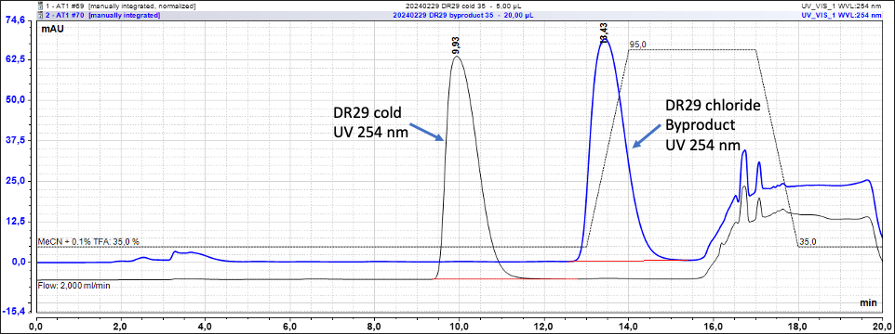
Figure S4. HPLC graph developed for purification after radiolabeling with overlapping cold standard of DR29 (black) and chloride by-product (blue).

Figure S5. Control experiments of immunohistochemical staining for both WKY/Izm (a, AT1R antibody (-); b, AT1R antibody (+)) and SHR/Izm (c, AT1R antibody (-); d, AT1R antibody (+)) kidney sections with and without primary antibody (AT1R antibody) under identical acquisition settings (magnification x40; bar = 500 μm). CTX, cortex; MDL, medulla.

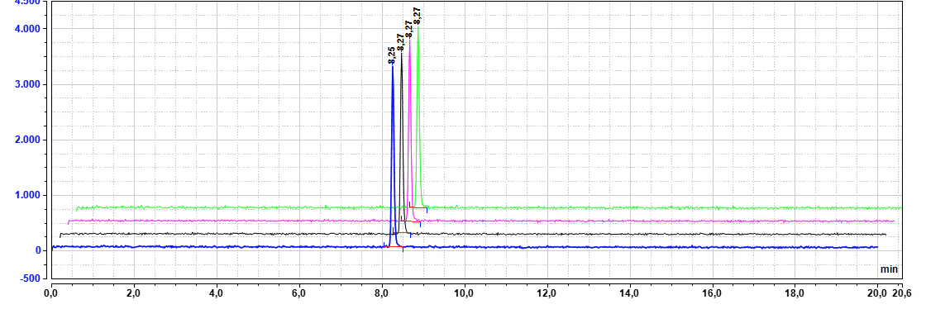
Figure S6. Quality control (blue) and in vitro stability of [¹⁸F]DR29 in final injection formulation (saline) at 0 (blue), 30 (black), 60 (magenta), and 120 (green) min after preparation.

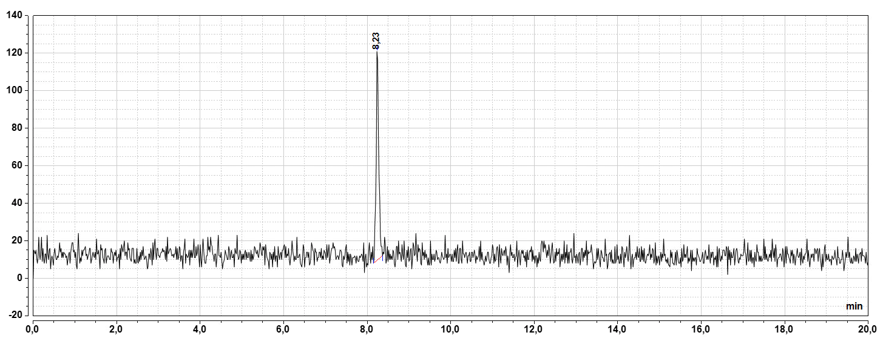
Figure S7. Representative HPLC analysis of [¹⁸F]DR29 in whole blood of rats treated with nitazoxanide and rifampicin 120 min after tracer injection.

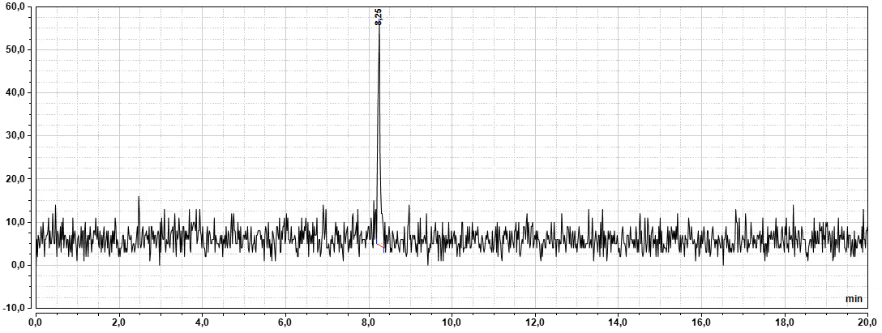
Figure S8. HPLC analysis of [¹⁸F]DR29 in whole blood of rats treated with nitazoxanide, rifampicin and candesartan 120 min after tracer injection.

