Supporting Information for

Amino acid substitutions in loop C of PIP2 aquaporins alters the permeability of
CO₂ in Arabidopsis.

Shaila Shermin Tania, Shigeko Utsugi, Yoshiyuki Tsuchiya, Shizuka Sasano, Maki
Katsuhara, and Izumi C Mori

Izumi C. Mori
E-mail: imori@okayama-u.ac.jp

This PDF file includes: Supplemental method Tables S1 to S2
Supplementary results: Figures S1 to S8

Supplemental method

Calculation of Pf
The rate of water transport into the oocytes were determined from the initial rate of inflation of the volume of the oocytes. The projected images of oocytes were captured using an inverted microscope equipped a charged-coupled device camera (Cool SNAP, Photometrics, Tucson, AZ, USA). The projected areas of oocytes were measured by ImageJ. Capturing the images were carried out from 0 to 90 seconds immediately after a quick perfusion of the bathing solution with 10-second intervals.

Pf was calculated from the measured projected areas by the equation (1).

𝑃 = 𝑉_{𝑡}
(1)

𝑓
𝑆₀
⋅ 𝑉_{𝖶}
⋅ Δ𝑂𝑠𝑚 ⋅ 𝑡

Vt is volume of the oocyte at time t, S0 is initial surface area of the oocyte, Vw is the volume of water. ΔOsm is the difference in the osmolality. t is time from start of the measurement. Vt and S0 are obtained as equations (2, 3)

𝑉_{𝑡} =
3
/ 𝑡
𝐴
4
3 π
(2)

𝑆₀ = 4 ⋅ 𝐴₀ (3)
At is projected area of oocyte at time t, A0 is the initial projected area of oocyte.

Calculation of PCO2
The pH changes in oocytes by perfusing high CO2 solution showed an apparent logarithmic decrease curve (Mori et al. 2014; Nakhoul et al. 1998; Figure 1B). PCO2 was calculated from the time constant (τ) of the logarithmic curve of pH decrement according to the equation (4).

𝑃 1 (𝑝𝐻𝑓−𝑝𝐾𝑎) ⋅ 𝑉
(4)

_{𝐶02} = τ ⋅ 10 𝑆
pHf is final pH of the oocyte, pKa is pKa of carbonic acid, V is volume of oocyte, S is surface area of oocyte.

Table S1. Primer sequences used for cloning of cDNA

Primers | Nucleotide sequence (5’ to 3’)
AtPIP2;1-F | GGAGATCTATGGCAAAGGATGTGGAAGC
AtPIP2;1-R | CCGCATGCTTAGACGTTGGCAGC
AtPIP2;2-F | ATGGCCAAAGACGTGGAAGGACCT
AtPIP2;2-R | TCAAACGTTGGCTGCACTTCTGAA
AtPIP2;3-F | GGAGATCTACAATGGCTAAAGACGTGG
AtPIP2;3-R | CCGCATGCTTAAACGTTGGCTGACTTC
AtPIP2;4-F | GGGCATGCACAATGGCAAAAGACTTGGATG
AtPIP2;4-R | CCGATATCTTAAGCAAAGC TCCTAAAGG
AtPIP2;5-F | GGGCAGCACAATGACGAAGGAAGTGG
AtPIP2;5-R | CCGATATCTTAAACGTGAGGCTGGCTC
AtPIP2;6-F | GGAGATCTAGAATGACGAAGGATGAGTTGACGG
AtPIP2;6-R | CCGCATGCTTAAGCATGGAGCTCATGAAGC
AtPIP2;7-F | GGAGATCTACAATGTCGAAAGAAGTGAGCG
AtPIP2;7-R | CCGCATGCTTAATTGGTTCCCTTGCTTC
AtPIP2;8-F | GGAGATCTACAATGTCAAAAGAACTCAGTGAAG
AtPIP2;8-R | CCGCATGCTCAATTGGTTGGGTTGCTG

Table S2. Primer sequences for chimeric constructs and amino acid substitutions

PIP2;1(N)-PIP2;3(C)  Insert forward (#1)  Insert reverse (#2)  Out forward (#3)  Out reverse (#4) | TGGCAGAACCATGGCAAAGGATGTGGAAGC GGCGATGACTGCTCTGTAGAAAGACCACTTCT GTGGTCTTTCTACAGAGCAGTCATCGCC  ATCCTTTGCCATGGTTCTGCCAAAGTTGAG
PIP2;3-PIP2;1-PIP2;3  Insert forward (#1)  Insert reverse (#2)  Out forward (#3)  Out reverse (#4) | GCATTTCAAAGCTCTTACTACACCCG GGTGCCTGTGCTGTAGCCATCG GATGGCTACAATACAGGCACCGGA  GTAGTAAGAGCTTTGAAATGCCTTCACAAAC
PIP2;1-PIP2;3-PIP2;1  Insert forward (#1)  Insert reverse (#2)  Out forward (#3)  Out reverse (#4) | AAGCCTTCCAAAGCTCTCACTATGTTAATTACGGT CGGTCCCTGTATTGTAGCCGTCAGCTAGAA CGGCTACAATACAGGGACCGGTCTA  AGTGAGAGCTTTGGAAGGCTTTGACAAAA
AtPIP313Y150H  Forward  Reverse | AAAGCTCTCACTACACCCGTTAC  CGGGTGTAGTGAGAGCTTTGAA
AtPIP313T152V  Forward  Reverse | CTCTTACTACGTTCGTTACGGAGGTGGAG  CCTCCGTAACGAACGTAGTAAGAGCTTTG
AtPIP313R153N  Forward  Reverse | CTTACTACACCAATTACGGAGGTGGAGC  CACCTCCGTAATTGGTGTAGTAAGAGC
AtPIP313S160F  Forward  Reverse | GGAGCCAACTTTCTAGCCGATGGC  CATCGGCTAGAAAGTTGGCTCCACC
AtPIP313S166N  Forward  Reverse | CGATGGCTACAATACAGGCACCGGACTC  CGGTGCCTGTATTGTAGCCATCGGCTAG
AtPIP2;1Y150H  Forward  Reverse | AAAGCTCTCACTACACCCGTTAC  CGGGTGTAGTGAGAGCTTTGAA
AtPIP2;1S160F  Forward  Reverse | GGAGCCAACTTTCTAGCCGATGGC  CATCGGCTAGAAAGTTGGCTCCACC
AtPIP2;3H147Y-F157S  AtPIP2;3HY forward AtPIP2;3HY reverse AtPIP2;3FS forward  AtPIP2;3FS reverse | CAAAGCTCTTACTATGTTAATTACG ATTAACATAGTAAGAGCTTTGAAATG GAGCCAACTCTCTAGCTGACGG  TCAGCTAGAGAGTTGGCTCCTCC

Supplementary results

Figure S1. Water permeability of PIP1 aquporins of Arabidopsis. Diffusion coefficient of water (P_{f}) of the cell membrane of X. laevis oocytes injected with water (n = 13), AtPIP2;1 cRNA (n = 6), AtPIP1;1 cRNA (n = 9), AtPIP1;2 cRNA (n = 9), AtPIP1;3 cRNA (n = 8), AtPIP1;4 cRNA (n = 9)
and AtPIP1;5 cRNA (n = 7). 25 ng cRNA was injected per oocyte. Different letters show significant difference (α = 0.05) by the Tukey- Kramer multiple comparison test. AtPIP2;1 serves as the positive control.
1.5

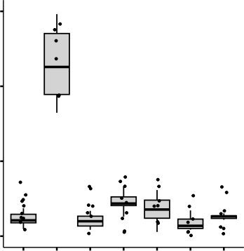
1.0
a
bc
b
bc
bc
c
bc
P_{f} (10-1 mmS-1)

0.5

0.0
Water
AtPIP2;1
AtPIP1;1
AtPIP1;2
AtPIP1;3
AtPIP1;4
AtPIP1;5

AtPIP2;1
AtPIP2;3

AtPIP2;1
AtPIP2;3
N-terminus
TM1

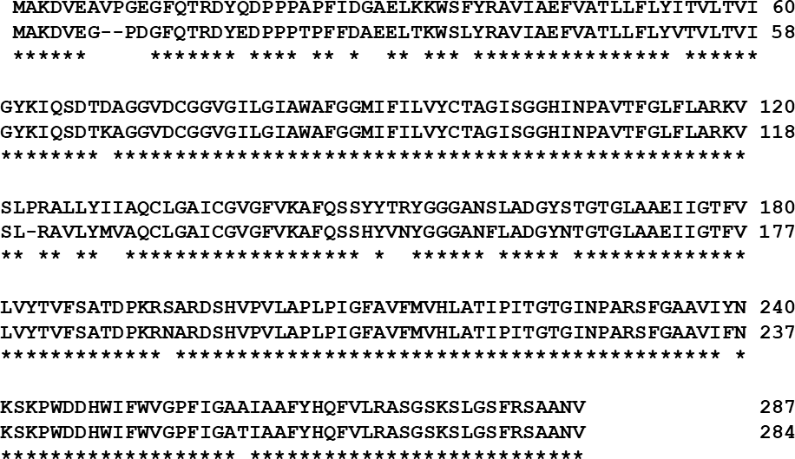
AtPIP2;1 AtPIP2;3
Loop A
TM2
Loop B
TM3
Loop C
TM4
Loop D
TM5
Loop E
TM6
C-terminus

AtPIP2;1
AtPIP2;3

AtPIP2;1
AtPIP2;3

Figure S2. Sequence alignment of apparent closer positioning AtPIP2;1 and AtPIP2;3 with distinct CO₂ permeability. Similarity 93.73% and Identity percentage is 90.94%.The red marked boxes indicating N-terminus and Loop C shows apparent higher polymorphism parts. The transmembrane domain and loops were predicted by TMHMM software (https://services.healthtech.dtu.dk/services/TMHMM-2.0/).

ar/R motif

AtPIP2;1 AtPIP2;3 AtPIP2;3^{H147Y-F157S}
NPA box
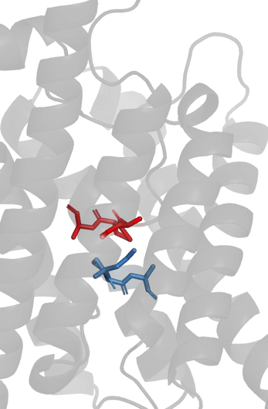
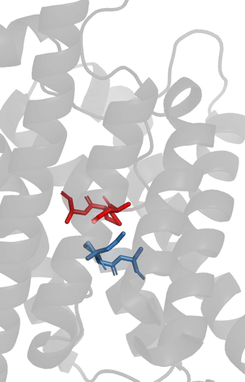
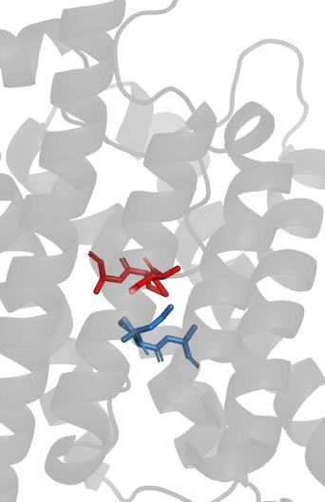
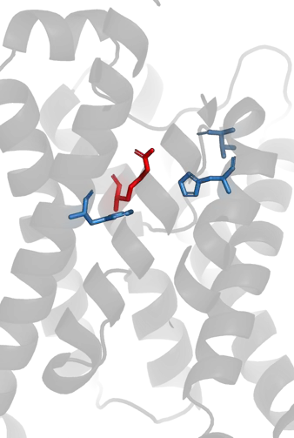
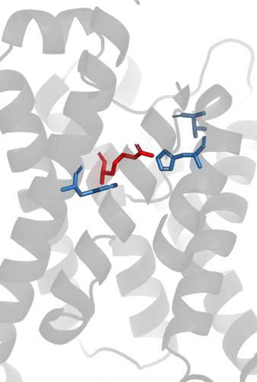
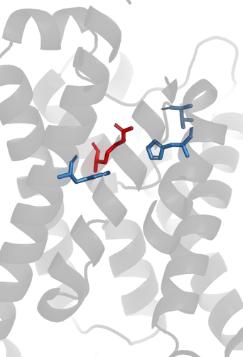
NPA box in loop E
NPA box in loop B
NPA box in loop E
NPA box in loop B
NPA box in loop E
NPA box in loop B
R-231
T-223
H-216
F-51
T-223
R-228
H-213
F-49
T-223
R-228
H-213
F-49

Figure S3. Conformation of sidechains of NPA boxes and ar/R motif in AtPIP2;1,
AtPIP2;3 and AtPIP2;3H147Y-F157S.

SiPIP2;1 SLVRALLYIVAQCLGAICGVGLVKAFQ-SAYFDRYGGGANSLASGYSRG HvPIP2;5 SLVRALLYMVAQCLGAMCGVGLVKAFQ-SAYFVRYGGGANTLAAGYSKG HvPIP2;3 SLVRAVLYIIAQCLGAICGVGLVKGFQ-SAFYVRYGGGANELSAGYSKG HvPIP2;4 SLVRAVLYIIAQCLGAICGVGLVKGFQ-SAFYVRYGGGANELSAGYSKG HvPIP2;1 SLIRALLYIIAQCLGAICGVGLVKGFQ-SSYYVRYGGGANELSAGYSKG SiPIP2;4 SLVRAVLYIIAQCLGAICGVGLVKGFQ-SAYFVRYGGGANELSAGYSKG AtPIP2;5 TLVRAVMYMVAQCLGAICGVALVKAFQ-SAYFTRYGGGANGLSDGYSIG AtPIP2;6 SLVRAVSYMVAQCLGATCGVGLVKVFQ-STYYNRYGGGANMLSDGYNVG AtPIP2;2 SLIRAVLYMVAQCLGAICGVGFVKAFQ-SSYYDRYGGGANSLADGYNTG AtPIP2;3 SLR-AVLYMVAQCLGAICGVGFVKAFQ-SSHYVNYGGGANFLADGYNTG AtPIP2;1 SLPRALLYIIAQCLGAICGVGFVKAFQ-SSYYTRYGGGANSLADGYSTG AtPIP2;4 SLVRTVLYIVAQCLGAICGCGFVKAFQ-SSYYTRYGGGANELADGYNKG NtPIP2;1 SLVRAIMYMLAQCLGAICGCGLVKAFQ-KAYYVKYGGGANTLNDGYNTG AtPIP2;7 SLVRALGYMIAQCLGAICGVGFVKAFM-KTPYNTLGGGANTVADGYSKG AtPIP2;8 SLPRAVAYMVAQCLGAICGVGLVKAFM-MTPYKRLGGGANTVADGYSTG SiPIP2;5 SLVRAALYIVAQCLGAICGAGLVRAFHGTSSYLRHGGGANELAAGYSKG HvPIP2;2 SLLRAVMYIVAQCAGGIVGAGIVKGIM-KDAYQANGGGANMVASGFSRG SiPIP2;7 SLLRTVLYIVAQCLGAICGVAIVKGIT-GDQYSLLGGGANSVADGFSVV

Figure S4. Alignment of deduced partial amino acid sequences of PIP2 aquaporins in Arabidopsis, tobacco, barley and foxtail millet. The red boxes indicate the position of critical amino acids found in this study. Blue color: CO₂-permeable aquaporins, red color: no or low CO₂-permeable aquaporins.

HvPIP2;3 HvPIP2;4
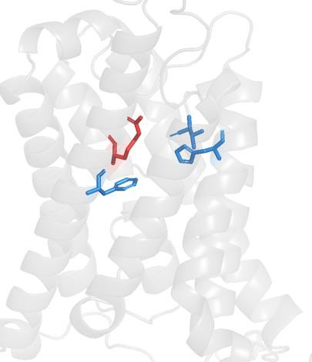
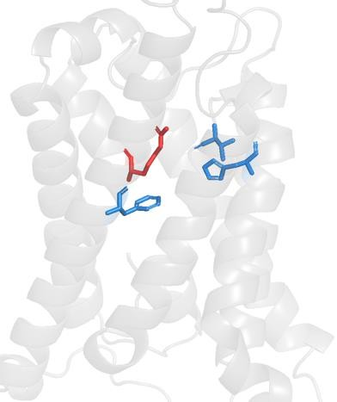
R-235
T-229
R-235
T-229
H-220
H-220
F-52
F-52

Figure S5. Three dimensional positions of sidechains of
ar/R motif in HvPIP2;3 and HvPIP2;4.

HvPIP2;2 SiPIP2;7 AtPIP2;7 AtPIP2;8
NtPIP2;1
AtPIP2;4
AtPIP2;1
AtPIP2;3 AtPIP2;2
AtPIP2;5 AtPIP2;6 HvPIP2;5 SiPIP2;1 SiPIP2;5 SiPIP2;4 HvPIP2;1 HvPIP2;3 HvPIP2;4

Figure S6. Phylogenetic tree of PIP2 aquaporins of Arabidopsis, tobacco (Nicotiana tabacum), barley (Hordeum vulgare) and foxtail millet (Setalia italica). Blue: CO₂/H₂O dual-permeable aquaporins, Red: no or low CO₂-permeable/H₂O- permeable aquaporins, Green (bolded for enhancing readability for individuals with color vision impairment): CO₂-permeable/no or low H₂O-permeable aquaporins. Phylogenetic tree was generated by ClustalW with Neighbour Joining method using the full-length amino acid sequences. The Gene Identifier codes are AtPIP2;1, At3g53420; AtPIP2;2, At2g37170; AtPIP2;3, At2g37180; AtPIP2;4, At5g60660; AtPIP2;5, At3g54820; AtPIP2;6, At2g39010; AtPIP2;7, At4g35100; AtPIP2;8, At2g16850; NtPIP2;1, AF440272; HvPIP2;1, AB219366; HvPIP2;2, AB377269; HvPIP2;3, AB275280; HvPIP2;4, AB219525; HvPIP2;5, AB377270; SiPIP2;1, 004956113.1; SiPIP2;4, 004953172.1; SiPIP2;5, 012698174.2; SiPIP2;7,
004957505.1.

TM3
Loop C
TM4

Arabidopsis PIP2;1 (P43286) YIIAQCLGAICGVGFVKAFQSS*YYTRYGGG ANS*LADGYSTGTGLAAEIIGTFVLVYTVFSA
Synechococcus AqpZ_(K9RY94) YIVAQVIGAVIAGGLVYLIASGRGGGFVLGGSNPLATNG FGAHSPGGYGLVAALITEVVMTFMFLLVILGA
Human AQP8 (O94778) YIIAQCVGAIVATAILSGISPEERFWNASG AAFVTVQEQGQVAGALVAEIILTTLLALAVCMG
Rat AQP8 (P56405) YIIAQCVGAIVATAILSGISPEERFWNASG AAFAIVQEQEQVAEALGVEIVMTMLLVLAVCMG
Human AQP1 (P29972) YIIAQCVGAIVATAILSGITSSLTGNSLG RNDLADGVNSGQGLGIEIIGTLQLVLCVLAT
Rat AQP1 (P29975) YIIAQCVGAIVATAILSGITSSLLENSLG RNDLARGVNSGQGLGIEIIGTLQLVLCVLAT
Bovine AQP1 (P47865) YIIAQCVGAIVATAILSGITSSLPDNSLG LNALAPGVNSGQGLGIEIIGTLQLVLCVLAT
Zebrafish AQP1a1 (Q6NZ72) YILAQMIGATVASAIVLGVSK---GDALG LNQIHTDISAGQGVGIELLATFQLVLCVLAT
Human AQP2 (P41181) YVAAQLLGAVAGAALLHEITPADIRGDLA VNALSNSTTAGQAVTVELFLTLQLVLCIFAS
Bovine AQP2 (P79099) YVAAQLLGAVAGAALLHEITPPAIRGDLA VNALNNNSTAGQAVTVELFLTLQLVLCIFAS
Rat AQP2 (P34080) YVAAQLLGAVAGAAILHEITPVEIRGDLA VNALHNNATAGQAVTVELFLTMQLVLCIFAS
Human AQP5 (P55064) YVAAQLVGAIAGAGILYGVAPLNARGNLA VNALNNNTTQGQAMVVELILTFQLALCIFAS
Rat AQP5 (P47864) YVAAQLVGAIAGAGILYWLAPLNARGNLA VNALNNNTTPGKAMVVELILTFQLALCIFAS
Human AQP6 (Q13520) YVAAQLVGATVGAALLYGVMPGDIRETLG INVVRNSVSTGQAVAVELLLTLQLVLCVFAS
Rat AQP6 {Q9WTY0) YIAAQLAGATVGAALLYGVTPGGVRETLG VNVVHNSTSTGQAVAVELVLTLQLVLCVFAS
Human AQP4 (P55087) YIAAQCLGAIIGAGILYLVTPPSVVGGLG VTMVHGNLTAGHGLLVELIITFQLVFTIFAS
Bovine AQP4 (O77750) YIAAQCLGAIIGAGILYLVTPPSVVGGLG VTTVHGNLSAGHGLLVELIITFQLVFTIFAS
Rat AQP4 (P47863) YITAQCLGAIIGAGILYLVTPPSVVGGLG VTTVHGNLTAGHGLLVELIITFQLVFTIFAS
Human AQP3 (Q92482) YTLAQTLGAFLGAGIVFGLYYDAIWHFADNQLFVSGPNGTAGIFATYPSGHLDMINGFFDQFIGTASLIVCVLAI Bovine AQP3 (Q08DE6) YTLAQTLGAFLGAGIIFGLYYDAIWAFANNQLIVSGPNGTAGIFATYPSGHLDMVNGFFDQFIGTASLIVCVLAI Rat AQP3 (P47862) YTLAQTLGAFLGAGIVFGLYYDAIWAFAGNELVVSGPNGTAGIFATYPSGHLDMVNGFFDQFIGTAALIVCVLAI Human AQP10 (Q96PS8) YILVQLLSAFCASGATYVLYHDALQNYTGGNLTVTGPKETASIFATYPAPYLSLNNGFLDQVLGTGMLIVGLLAI Human AQP9 (O43315) YVGAQFLGAFVGAATVFGIYYDGLMSFAGGKLLIVGENATAHIFATYPAPYLSLANAFADQVVATMILLIIVFAI Rat AQP9 (P56627) YVGAQFLGAFVGAATVFGIYYDGLMAFAGGKLLVVGENATAFIFATYPAPFISTPGAFVDQVVSTMFLLLIVFAM Human AQP7 (O14520) YVLGQFLGSFLAAATIYSLFYTAILHFSGGQLMVTGPVATAGIFATYLPDHMTLWRGFLNEAWLTGMLQLCLFAI Rat AQP7 (P56403) YVLGQFLGSFLAAATTYLIFYGAINHYAGGELLVTGPKSTANIFATYLPEHMTLWRGFVDEVFVTGMLQLCIFAI Human AQP11 (Q8NBQ7) RLLAQLVSALCSRYCTSALWSLGLTQYHVSE RSFACKNPIRVDLLKAVITEAVCSFLFHS
Rat AQP11 (Q8CHM1) RLMAQLVSALCSRYCISALWSLSLTKYHFDE RILACRNPINTDISKAIIIEAICSFIFHS
Human AQP12 (Q8IXF9) KLAAQGLGMQAACTLMRLCWAWELSDLHLLQS LMAQSCSSALRTSVPHGALVEAACAFCFHL
Rat AQP12a (D4A9T6) KLLAQVLGAQAACALTQRCWTWELSELHLLQS LMAVHCSSTLRTSVLQGTLVEGACTFLFHL

Figure S7. Amino acid sequence alignment of transmembrane domain (TM) 3, loop C and TM4 of aquaporins of human, rat, bovine, Synechococcus sp. PCC7942 AqpZ and Arabidpsis thaliana PIP2;1. Asterisks indicate Tyr-150 and Ser-160 in Arabidopsis PIP2;1. Accession numbers are shown in parentheses.

0.02
PIP2;4/ACTIN
a

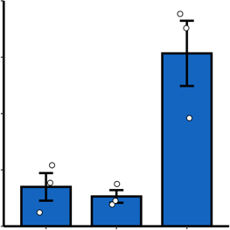
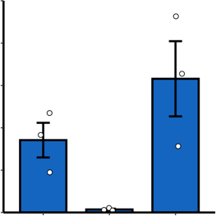
0.2
b
b
ab
b
PIP2;2/ACTIN
a

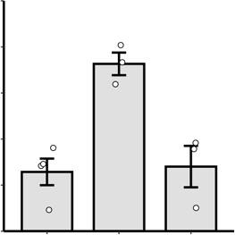
0.04
a
b
b
PIP2;3/ACTIN
0.010

0.01
PIP2;1/ACTIN

0.1

0.02
0.005

0.00

0.03
0.0
WL MCP GC WL MCP GC
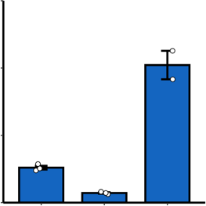
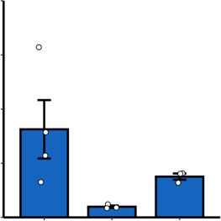
0.8
a
b
b
a
ab
b
0.00

0.3

WL MCP GC
0.000

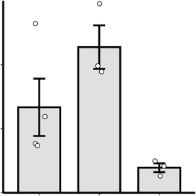
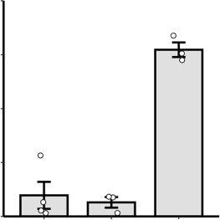
0.004
ab
a
b
a
b
b

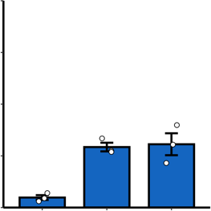
WL MCP GC
a
a
b

0.02
PIP2;5/ACTIN

0.01

0.4
0.2

0.1
PIP2;7/ACTIN

0.002

0.00
PIP2;6/ACTIN
PIP2;8/ACTIN
0.0
WL MCP GC WL MCP GC
0.0

WL MCP GC
0.000

WL MCP GC

Figure S8. Relative expression of AtPIP2 genes relative to that of ACTIN in whole leaf (WL), mesophyll cell protoplasts (MCP) and guard cell-enriched epidermis (GC) of Arabidopsis thaliana ecotype Columbia. Blue bars and white bars indicate CO₂-permeating and CO₂-non-permeating aquaporins, respectively. Different letters show the significant difference (α = 0.05) by the Tukey- Kramer multiple comparison test. The relative expression level was calculated using the ΔΔC_{t} method with the reference gene (ACTIN2/8) as an internal standard.

