Supplementary Information

Title:
Direct insertion of an ion channel immobilized on a soft agarose gel bead into a lipid bilayer: an optimized method

Journal name:
Analytical Sciences

Author names:
Mami Asakura^{1, 2}, Shuyan Wang¹, Minako Hirano¹, Toru Ide^{1*}

Affiliation:
1 Graduate School of Interdisciplinary Science and Engineering in Health Systems, Okayama University, 3-1-1 Tsushima-naka, Kita-ku, Okayama-shi, Okayama, 700-8530, Japan
2 Department of Comprehensive Technical Solutions, Okayama University, 3-1-1 Tsushima-naka, Kita-ku, Okayama-shi, Okayama, 700-8530, Japan

E-mail address of the corresponding author:
ide@okayama-u.ac.jp (Toru Ide)

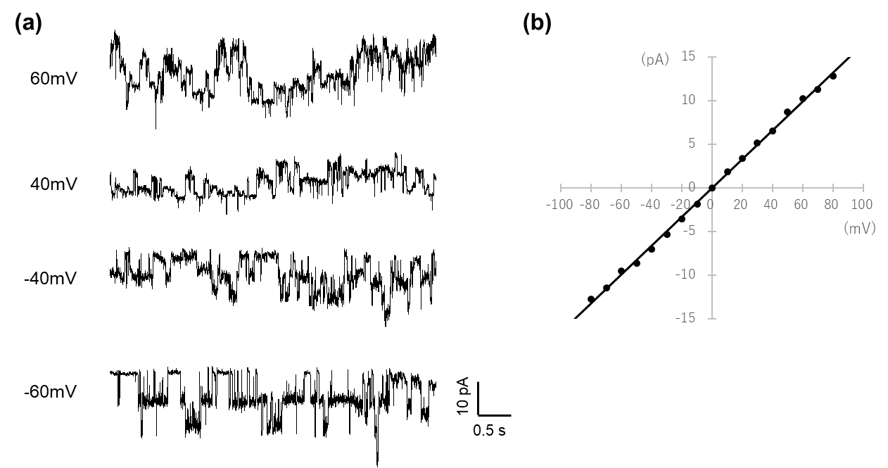
Fig. S1
(a) Channel current recording for KcsA E71A, which has an N-terminal His-tag attached to a Ni-NTA agarose bead₍₂₎. The recording solution consisted of 200 mM KCl and 10 mM succinic acid at pH 4.0. (b) I-V relation of KcsA E71A N-His. The single channel conductance was determined to be 153 ± 14 pS (n=4).

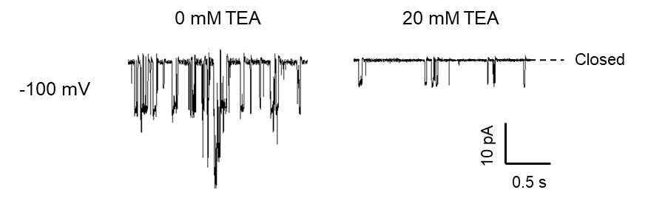
Fig. S2
Effects of tetraethylammonium (TEA) on the activity of wild-type KcsA, which has an N-terminal His-tag attached to a Ni-NTA agarose bead. The recording solution contained 200 mM KCl and 10 mM succinic acid at pH 4.0. TEA was applied at a final concentration of 20 mM; 0 mM TEA served as the control.

