Supplementary Information

Title:
Efficient single-channel current measurements of the human BK channel using a liposome-immobilized gold probe

Journal name:
Analytical Sciences

Author names:
Minako Hirano*, Mami Asakura, Toru Ide

Affiliation
Graduate School of Interdisciplinary Science and Engineering in Health Systems, Okayama University, 3-1-1 Tsushima-naka, Kita-ku, Okayama-shi, Okayama 700-8530, Japan

E-mail address of the corresponding author:
hirano37@okayama-u.ac.jp (Minako Hirano)

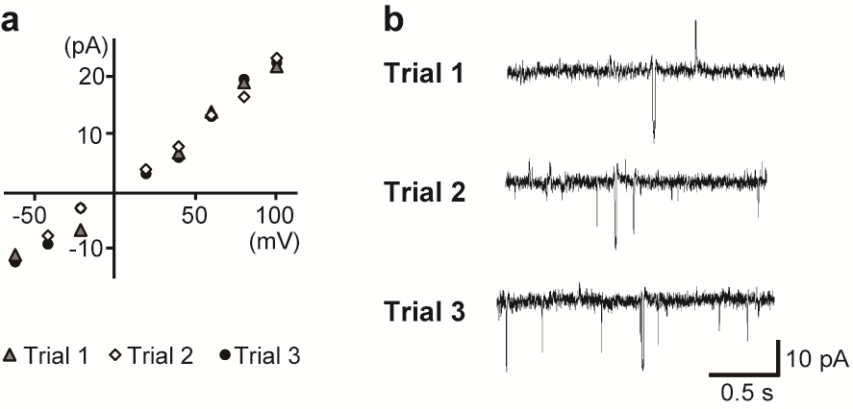

Figure S1. Single-channel current recordings of the hBK channel measured multiple times using the probe with hBK channel-containing liposomes ("Probe-hBK-Liposome"). (a) Current-voltage relationships of the hBK channel measured in trial 1, 2, and 3. (b) Typical single-channel current traces of the hBK channel at +80 mV from each measurement.

